[](http://www.comsol.com/)

Ex1 DuongThuPhuong 22BI13362

Report date

Nov 1, 2023 3:14:12 PM

Contents

1. Global Definitions

1.1. Parameters

2. Component 1

2.1. Definitions

2.2. Geometry 1

2.3. Materials

2.4. Laminar Flow

2.5. Mesh 1

3. Study 2

3.1. Stationary

4. Results

4.1. Datasets

4.2. Plot Groups

1. Global Definitions

|  |  |
| --- | --- |
| Date | Nov 1, 2023 3:08:41 PM |

Global settings

|  |  |
| --- | --- |
| Name | Ex1 DuongThuPhuong 22BI13362.mph |
| Path | C:\Users\AE\Desktop\dtp\Ex1_DuongThuPhuong_22BI13362.mph |
| Version | COMSOL Multiphysics 5.5 (Build: 359) |

Used products

|  |
| --- |
| COMSOL Multiphysics |
| Design Module |

* 1. Parameters

Parameters 1

| **Name** | **Expression** | **Value** | **Description** |
| --- | --- | --- | --- |
| x0 | 0 | 0 |  |
| y0 | 0 | 0 |  |
| x1 | 0.15 | 0.15 |  |
| y1 | 0.1 | 0.1 |  |

1. Component 1
   1. Definitions
      1. Coordinate Systems

#### Boundary System 1

|  |  |
| --- | --- |
| Coordinate system type | Boundary system |
| Tag | sys1 |

Coordinate names

| **First** | **Second** | **Third** |
| --- | --- | --- |
| t1 | n | to |

* 1. Geometry 1

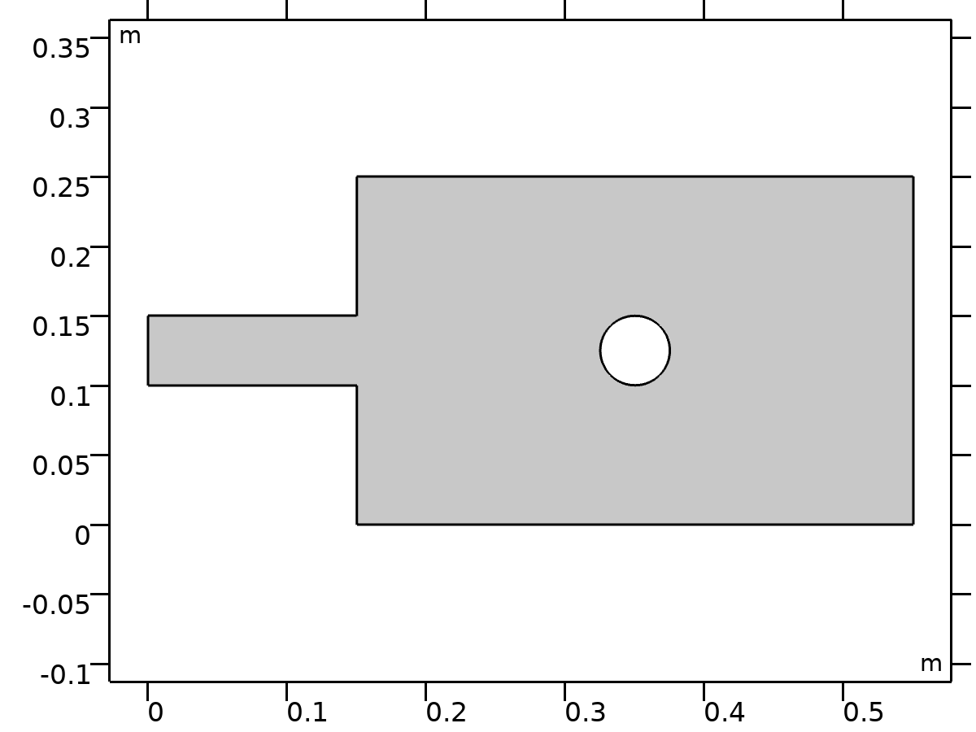

Geometry 1

Units

|  |  |
| --- | --- |
| Length unit | m |
| Angular unit | deg |

* 1. Materials
     1. Water

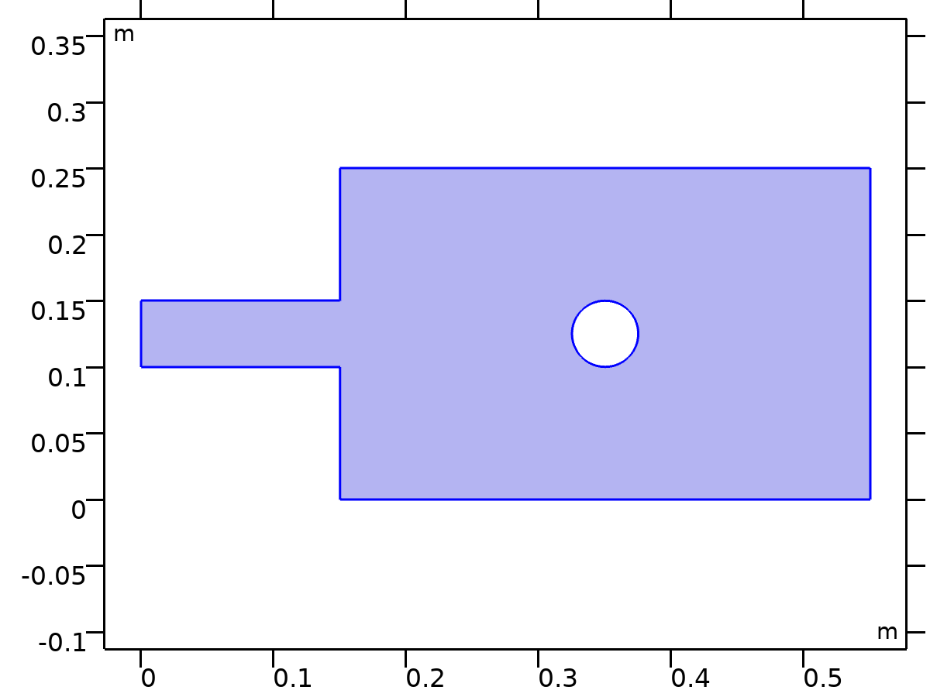

Water

Selection

|  |  |
| --- | --- |
| Geometric entity level | Domain |
| Selection | Geometry geom1: Dimension 2: All domains |

* 1. Laminar Flow



Laminar Flow

Equations





Features

|  |
| --- |
| Fluid Properties 1 |
| Initial Values 1 |
| Wall 1 |
| Inlet 1 |
| Outlet 1 |

* + 1. Fluid Properties 1

Equations





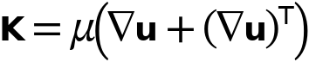

* + 1. Wall 1

Equations



* + 1. Inlet 1

Equations



* + 1. Outlet 1

Equations





* 1. Mesh 1

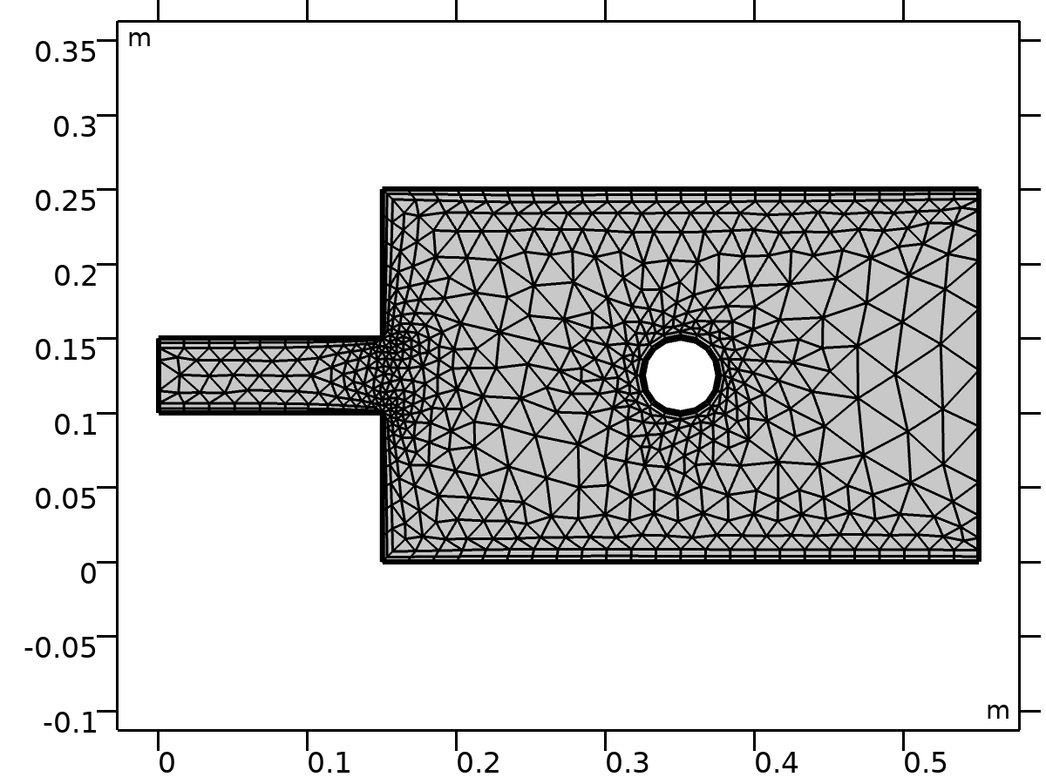

Mesh 1

1. Study 2

Computation information

|  |  |
| --- | --- |
| Computation time | 4 s |
| CPU | Intel64 Family 6 Model 142 Stepping 12, 4 cores |
| Operating system | Windows 10 |

* 1. Stationary

Study settings

| **Description** | **Value** |
| --- | --- |
| Include geometric nonlinearity | Off |

Physics and variables selection

| **Physics interface** | **Discretization** |
| --- | --- |
| Laminar Flow (spf) | physics |

Mesh selection

| **Geometry** | **Mesh** |
| --- | --- |
| Geometry 1 (geom1) | mesh1 |

1. Results
   1. Datasets
      1. Study 2/Solution 2

Solution

| **Description** | **Value** |
| --- | --- |
| Solution | Solution 2 |
| Component | Save Point Geometry 1 |

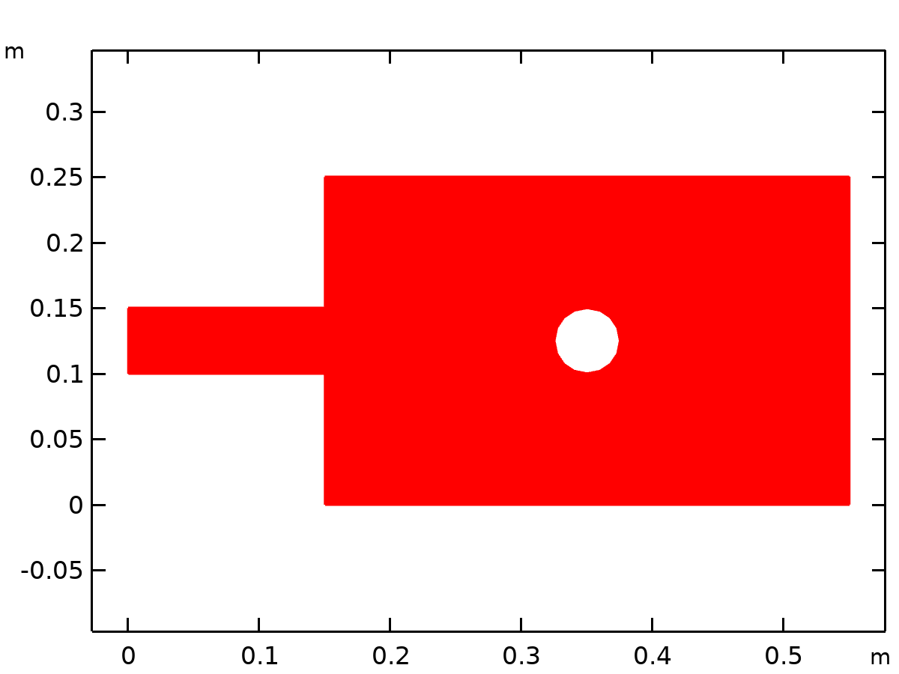

Dataset: Study 2/Solution 2

* 1. Plot Groups
     1. Velocity (spf)

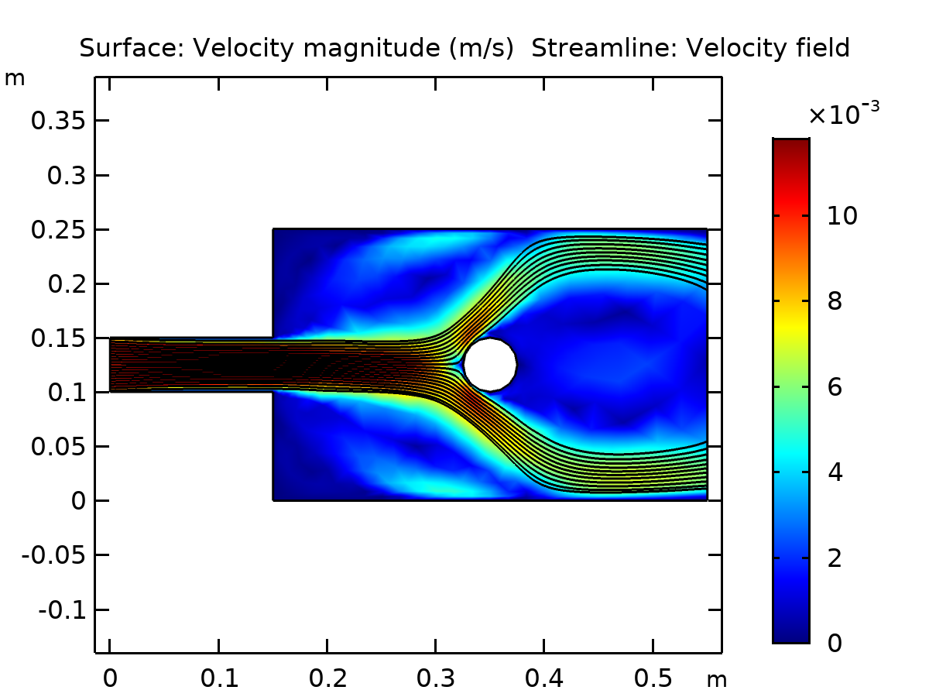

Surface: Velocity magnitude (m/s) Streamline: Velocity field

* + 1. Pressure (spf)

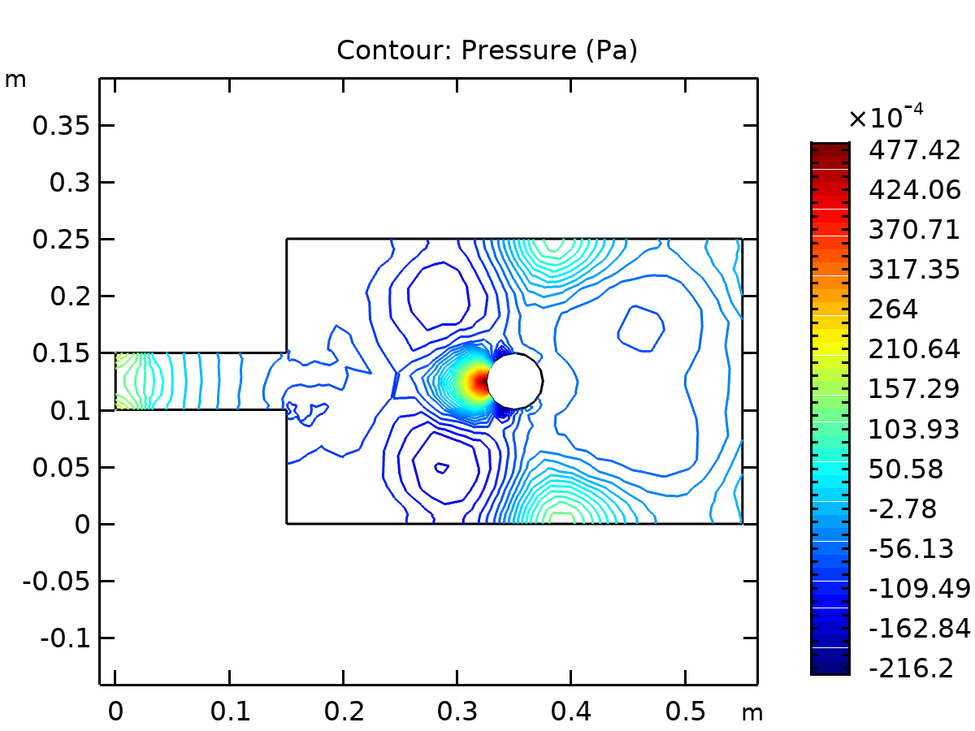

Contour: Pressure (Pa)